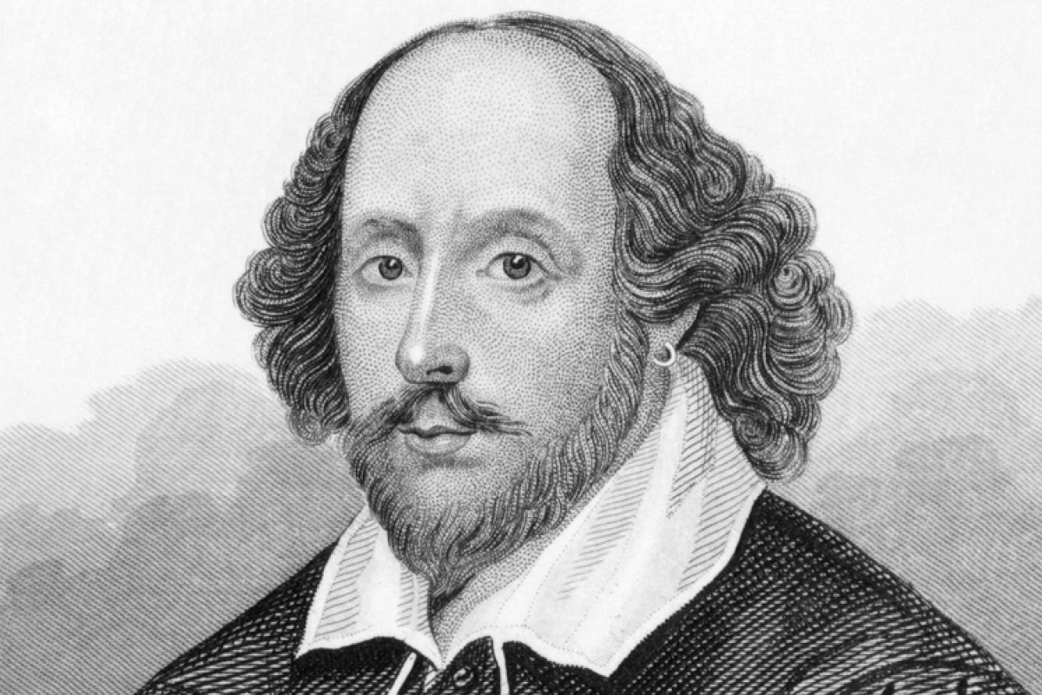
Name William Shakespeare, also called “……………………………………..”

Occupation Playwright, poet, actor

Born in ............

Died ............

Literary period Renaissance

Genre Renaissance Drama

Where were Shakespeare’s plays performed?
In 1599, Shakespeare’s company, the Lord Chamberlain’s Men took up residence in the newly built Globe. Julius Caesar was one of the first plays performed there. Performances at the Globe were divided into three seasons with breaks around Christmas when the players performed at court; Lent, when playing was intermittent; and summer when the players toured the provinces escaping the infection and infestation of the city.
- See more at: https://www.bl.uk/people/william-shakespeare#sthash.b0bNxA1l.dpuf

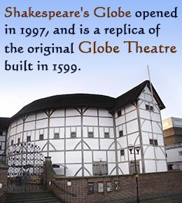
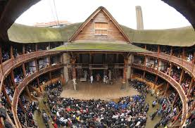
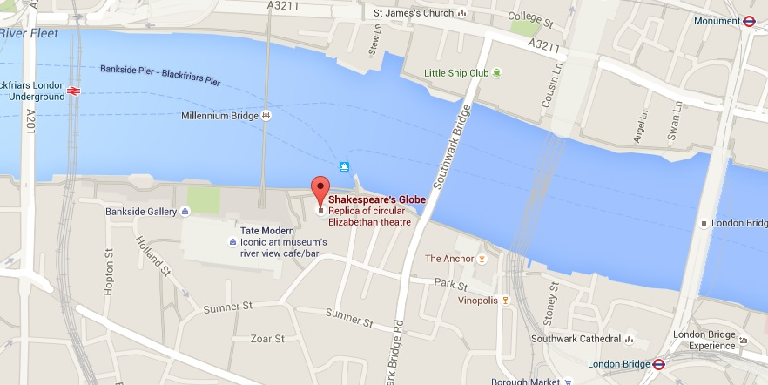
FACTS ABOUT THE GLOBE THEATRE
- The Globe Theatre was built between 1597 and 1599 in Southwark on the south bank of London’s River Thames,
- The Globe was built as a large, round, open air theatre. There was a roof around the circumference which covered the seating area, but most people were standing up.
- The Globe had three stories of seating and was able to hold up to 3,000 spectators.
- The plays lasted 3-4 hours. People were allowed to eat and drink during the play.
- People shouted and threw vegetables to the actors if they didn’t like the play.
- There were no actresses; only boys dressed like women could play female roles.
- A trumpet announced the beginning of the play. There were no curtains between scenes.
- Colour coded flags were used outside the theatre to advertise the type of play to be performed – a red flag for a history play, white for a comedy play and black for a tragedy play.
- The Globe Theatre burnt down in 1613 when a special effect on stage went wrong. A cannon used for a performance of Henry VIII set light to the thatched roof and the fire quickly spread.
- In 1613 the Globe burned down and the same year Shakespeare retired from the London theatre world and returned to Stratford. He died on 23 April 1616 and was buried in Holy Trinity Church, where he had been baptised 52 years earlier.

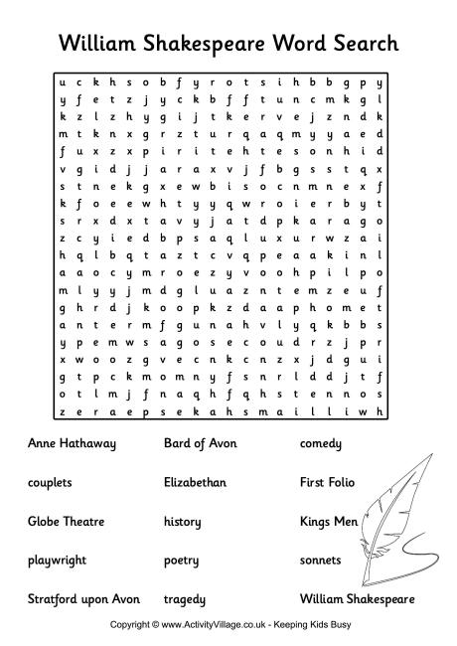

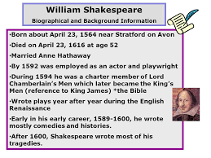

Chronology of Shakespeare's tragedies
Titus Andronicus (1591–1593)
Romeo and Juliet (1594-1595)
Julius Caesar (1599-1600)
Hamlet (1600–1601)
Troilus and Cressida (1601-1602)
Othello (1604–1605)
King Lear (1605–1606)
Macbeth (1605-1606)
Timon of Athens (1605–1608)
Antony and Cleopatra (1606-1607)
Coriolanus (1607-1608)
The Tempest (1610-1611)

List of comedies by William Shakespeare
Love's Labour's Lost - 1594-95
Measure for Measure - 1604 December 26
Merchant of Venice - 1596-97
Merry Wives of Windsor - 1600-01
Midsummer Nights Dream - 1595-96
Much Ado About Nothing - 1598-99
Pericles, Prince of Tyre - 1608-09
Taming of the Shrew - 1593-94
Troilus and Cressida - 1601-02
Twelfth Night-1602
Two Gentlemen of Verona - 1594-95
Winter's Tale - 1611-12

- When was Shakespeare born? And where?
- What was his occupation?
- Why did they have to rebuild “The Globe” theatre?
- How was a play in that theatre? What did the audience do?
- Were there any actresses? Who played their roles?
- Why is Shakespeare so famous?

The Project - Stages

- In groups of 2-3 people choose ONE of Shakespeare’s tragedies or comedies from the list above (except A Midsummers Night!).
- Find information about the play: a video of the play or a movie based on the play on YouTube, a book, a poster, etc.
- Prepare a Prezi presentation (Use https://prezi.com/prezi-for-education/) with images, texts, videos or animations.
- Show it to the teacher to check all mistakes (You get your Writing mark – 10%).
- Present it to the rest of the class (You get your Speaking mark- 5%)
- Your group gets your final mark for the project!
- Now you can include your project in your Portfolio.

