Lesson Plan 4 ESO C

Membres del grup: Ann Denzel Ison Arconado
Susana Yu

Material: màrfagues

Objectiu: tonificar i augmentar glutis, abdominals i cames, i millorar el nostre cos amb activitats i dinàmiques i individuals de manera que el resultat sigui positiva

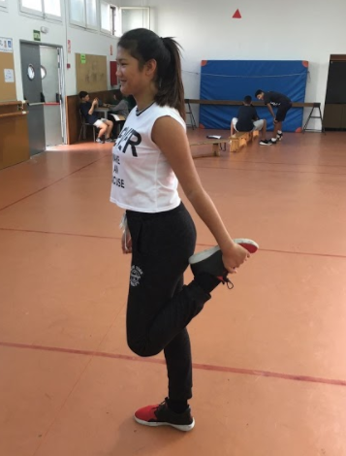
Individually activities:

- Strech 30’’
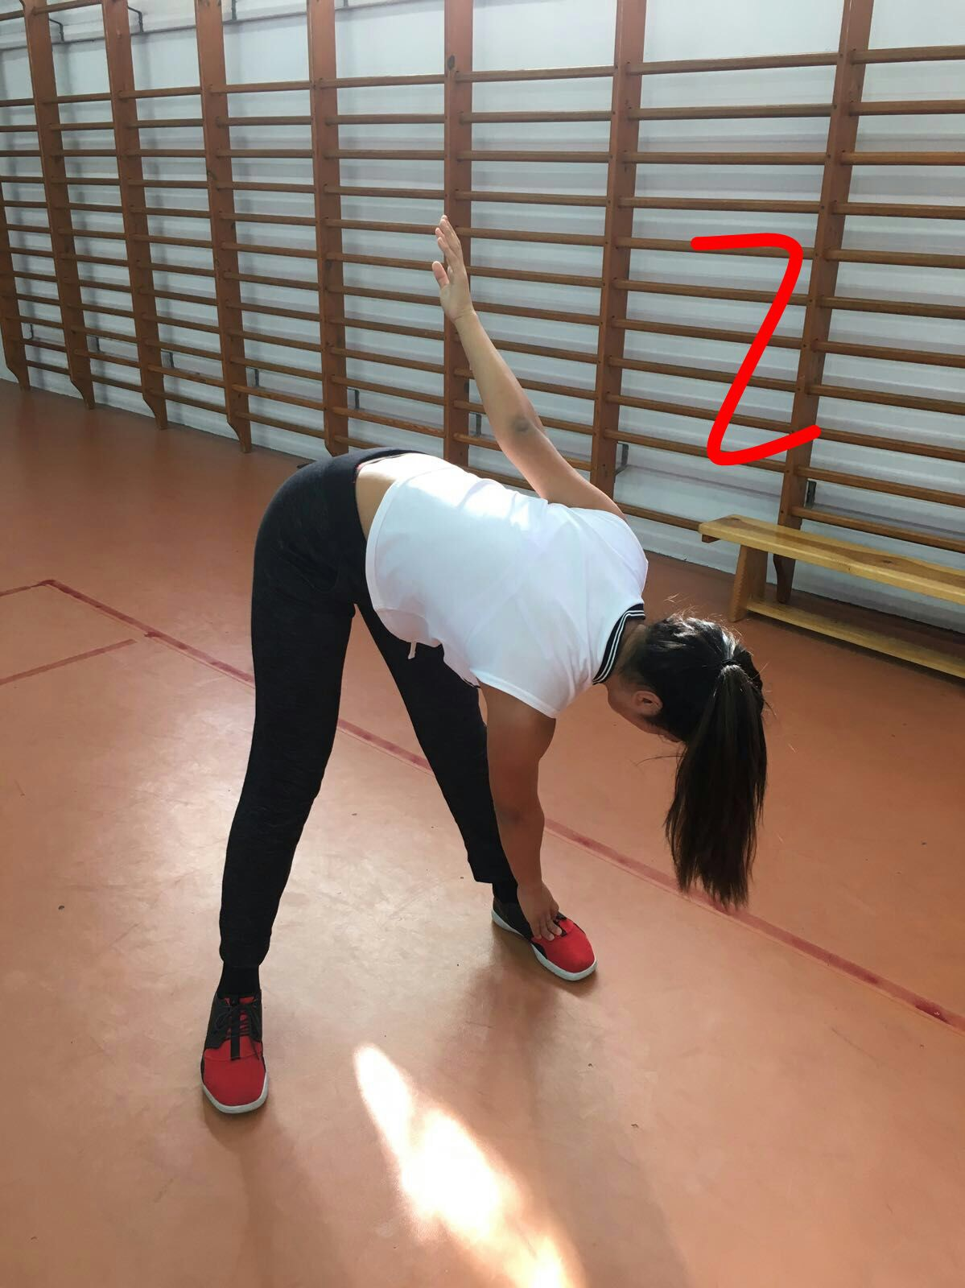
take one leg and push it towards your gluti

2. Worm up 30’’
separate the legs and you have to go touching the tips of your feet

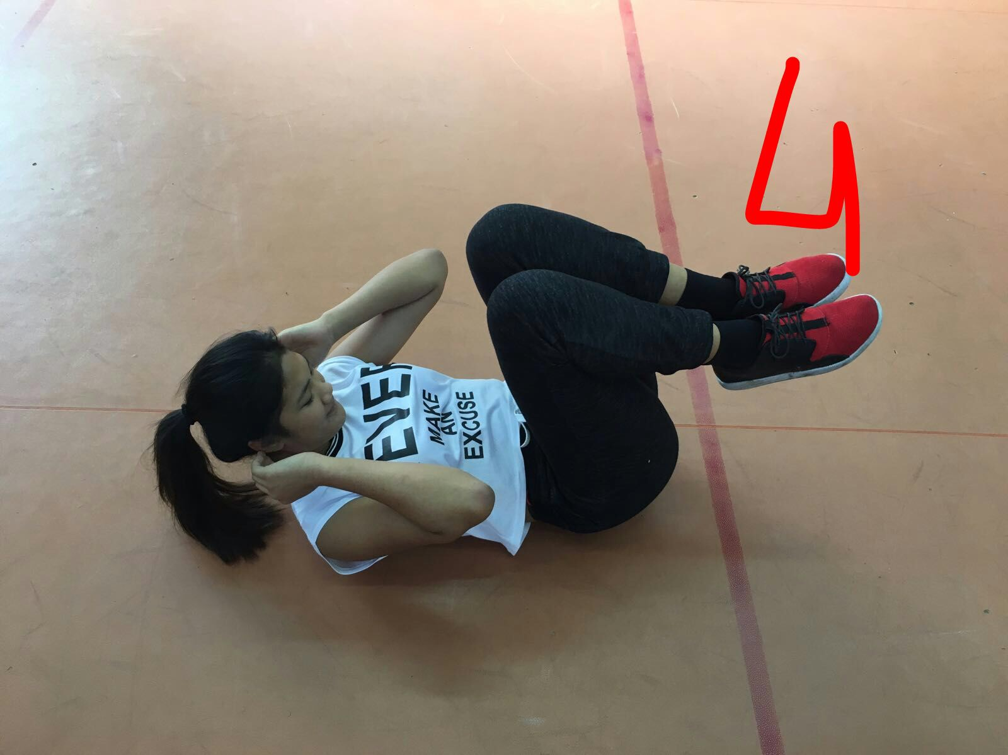

4. Crunch 30’’
With the leg hanging you have to bend your knees as far as you can

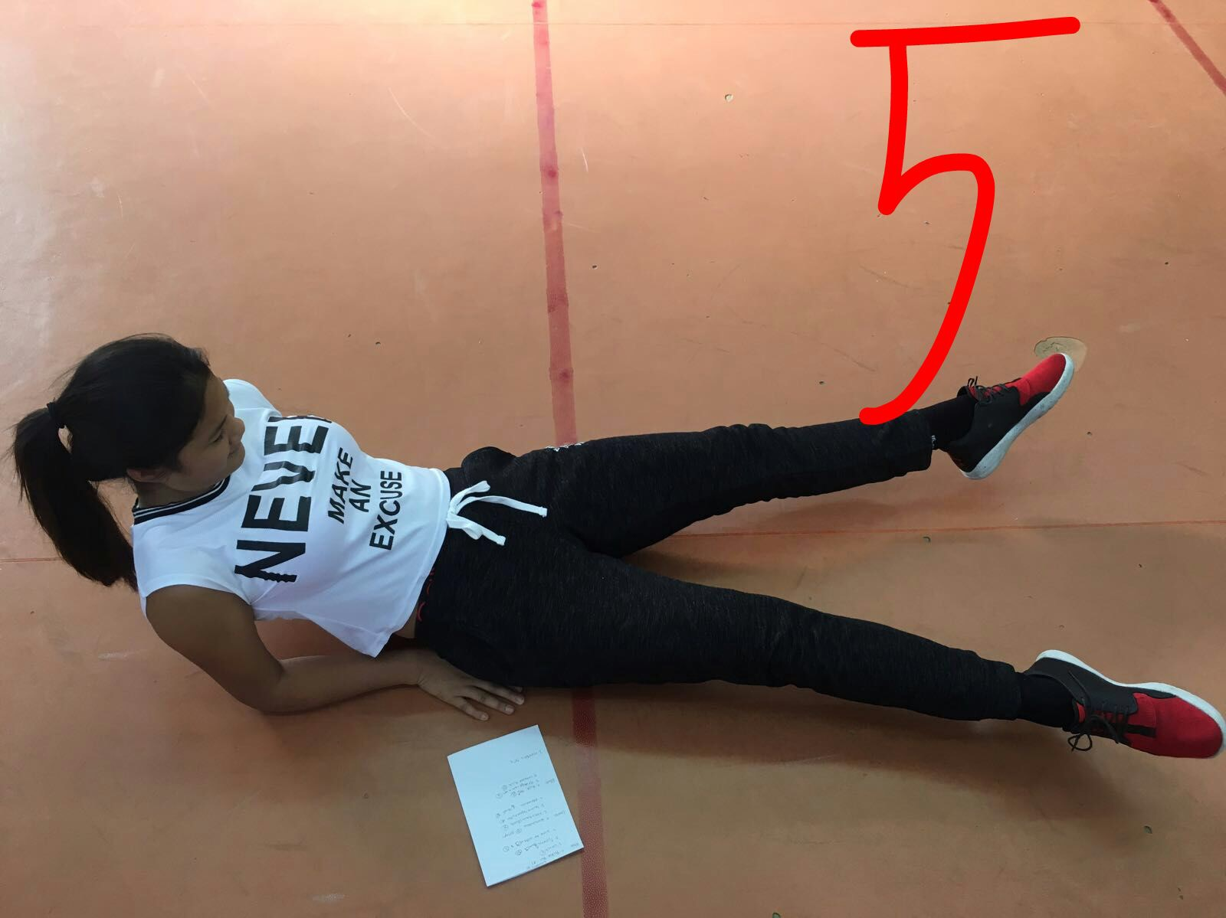

5. Tisors 30’’
Hang your legs and let's close and open like scissors

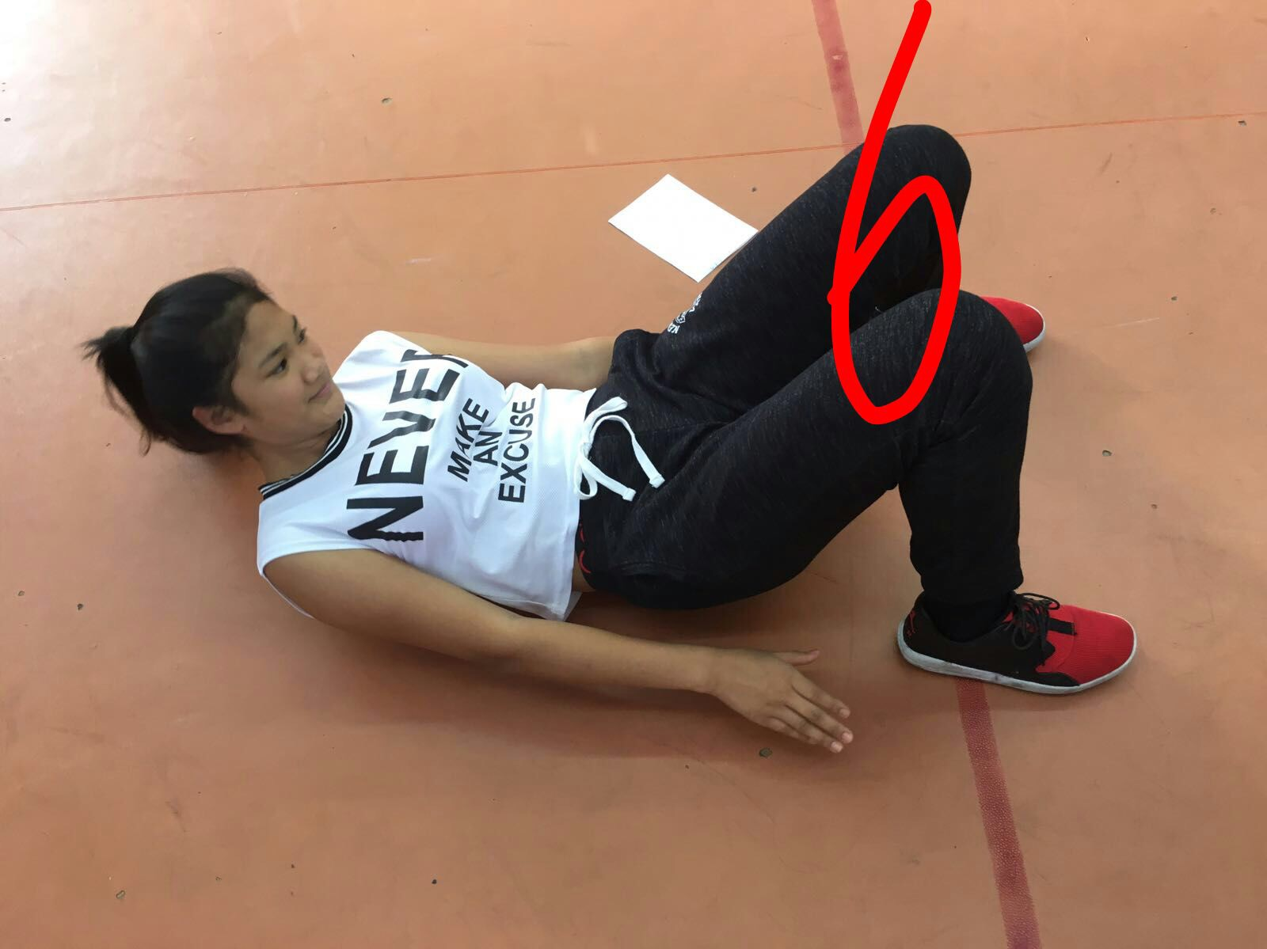

6. Side to side 30’’
bend your knees and reach the heels of your feet

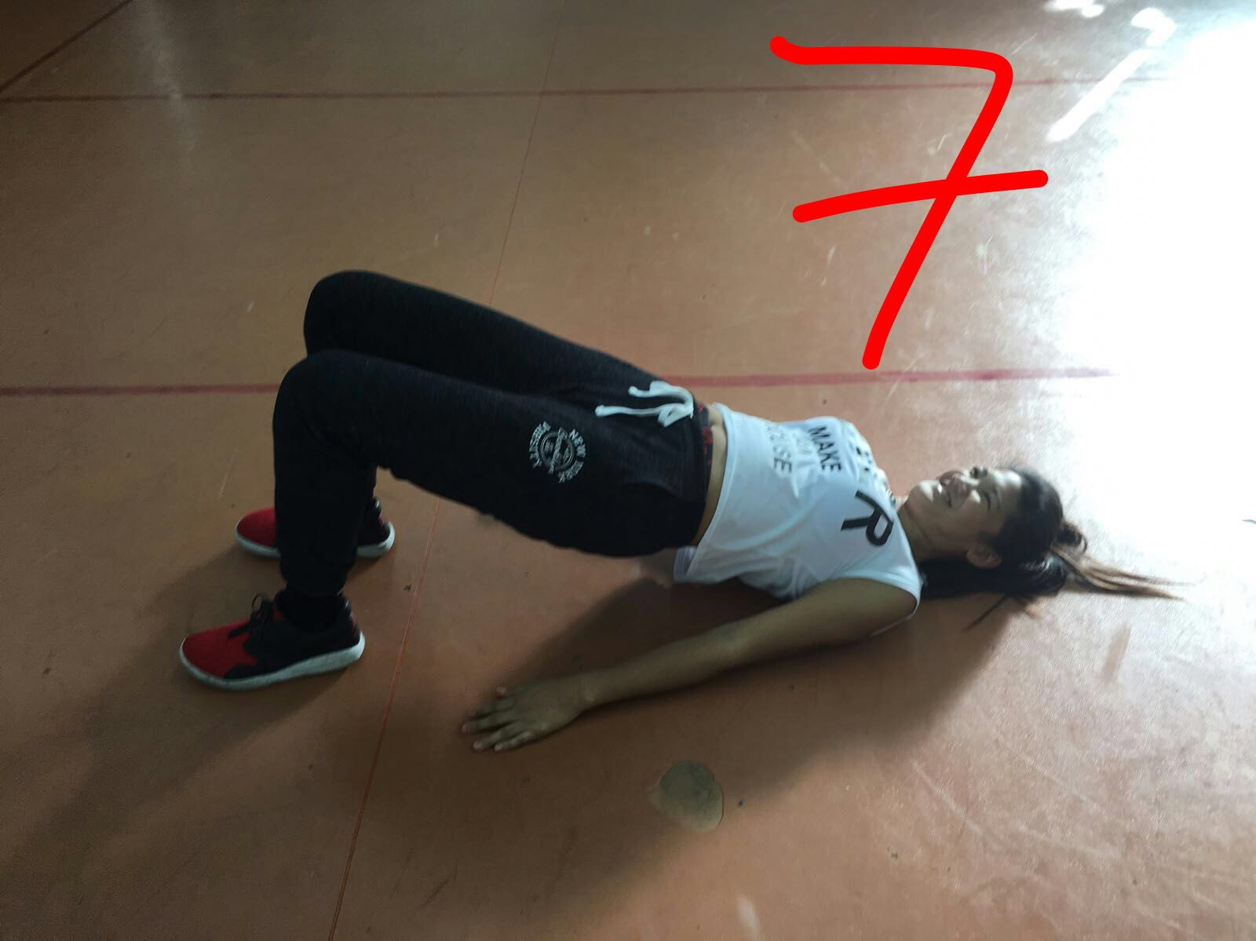

7. The bridge 30’’

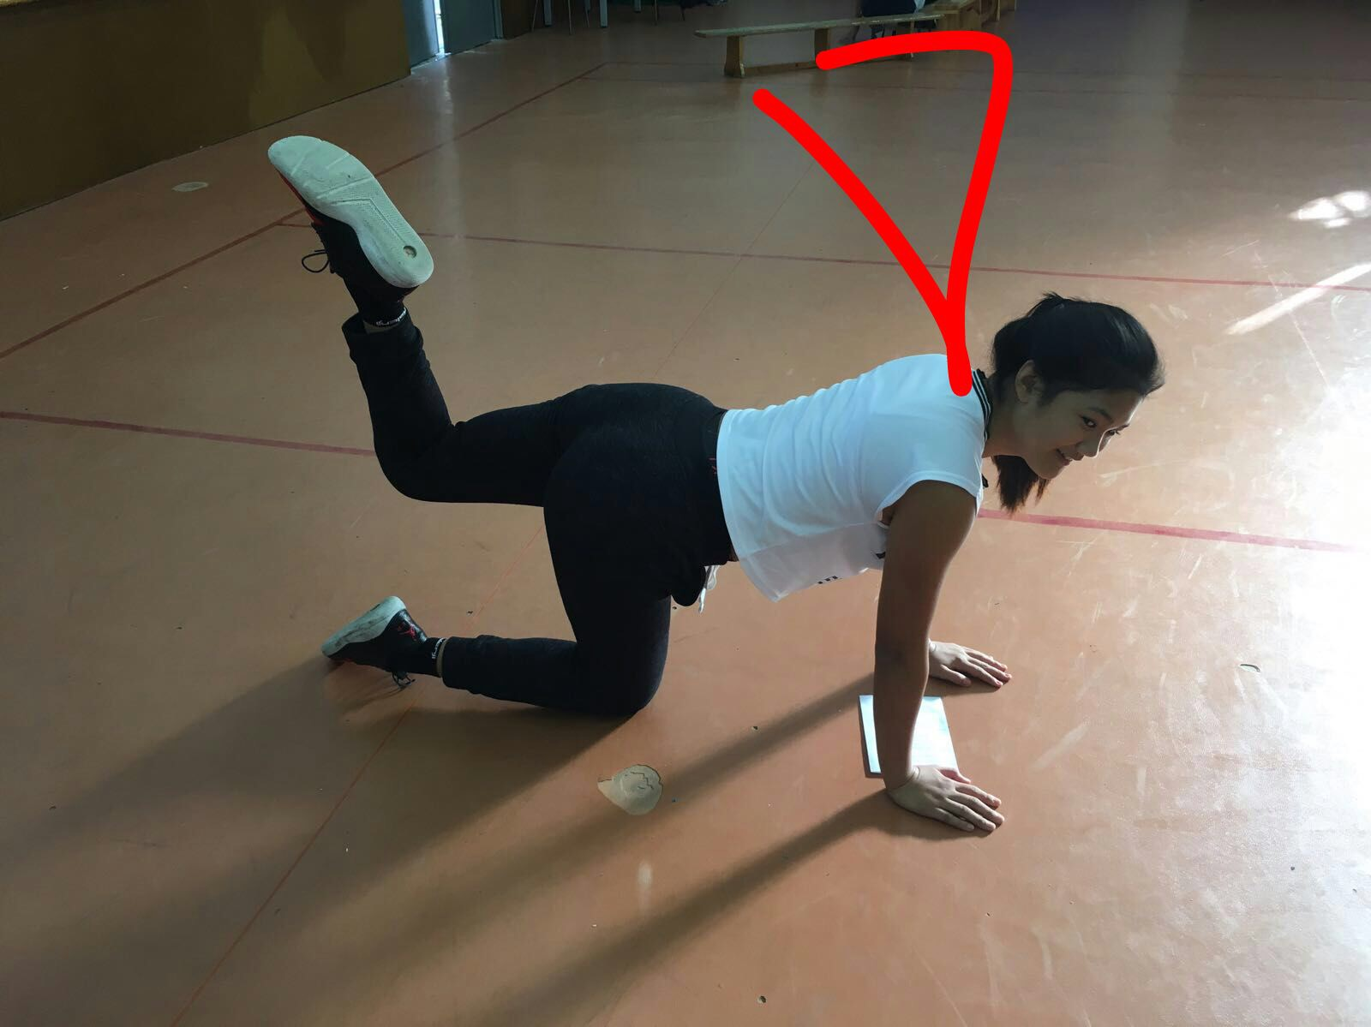

8. Kicks 30’’

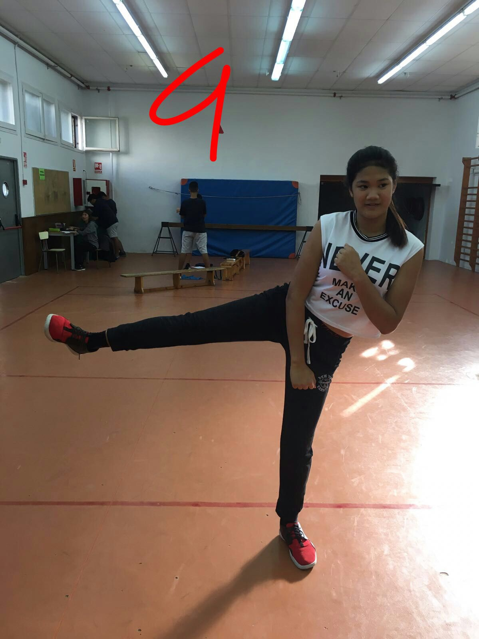

11 Lateral kick 30’’

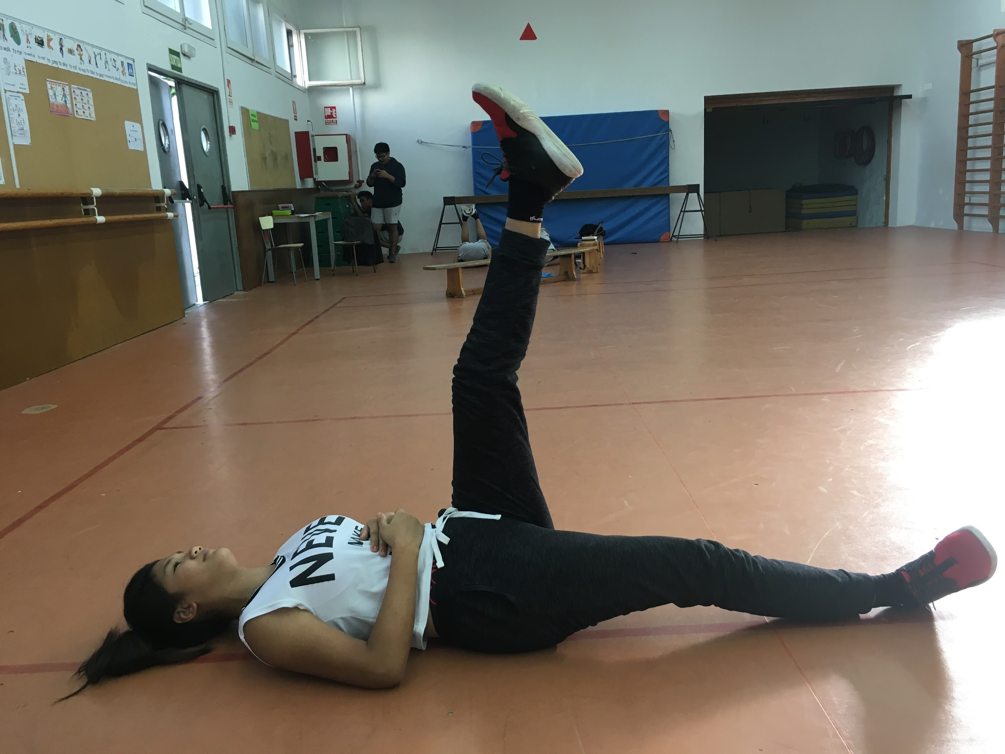

9. Elevation 30’’

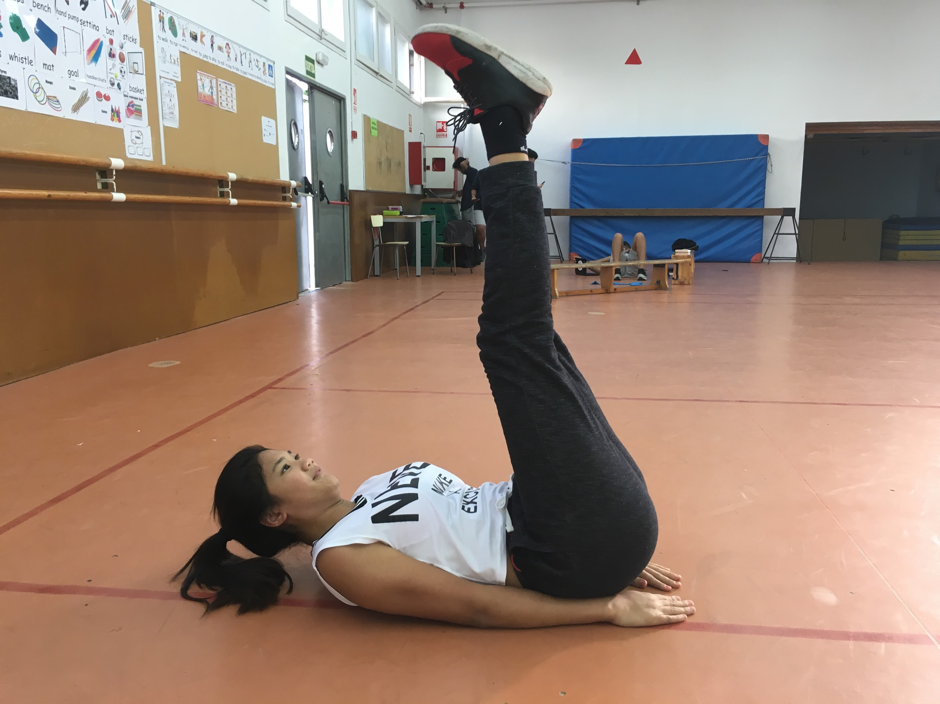

10. Touch the sky 30’’

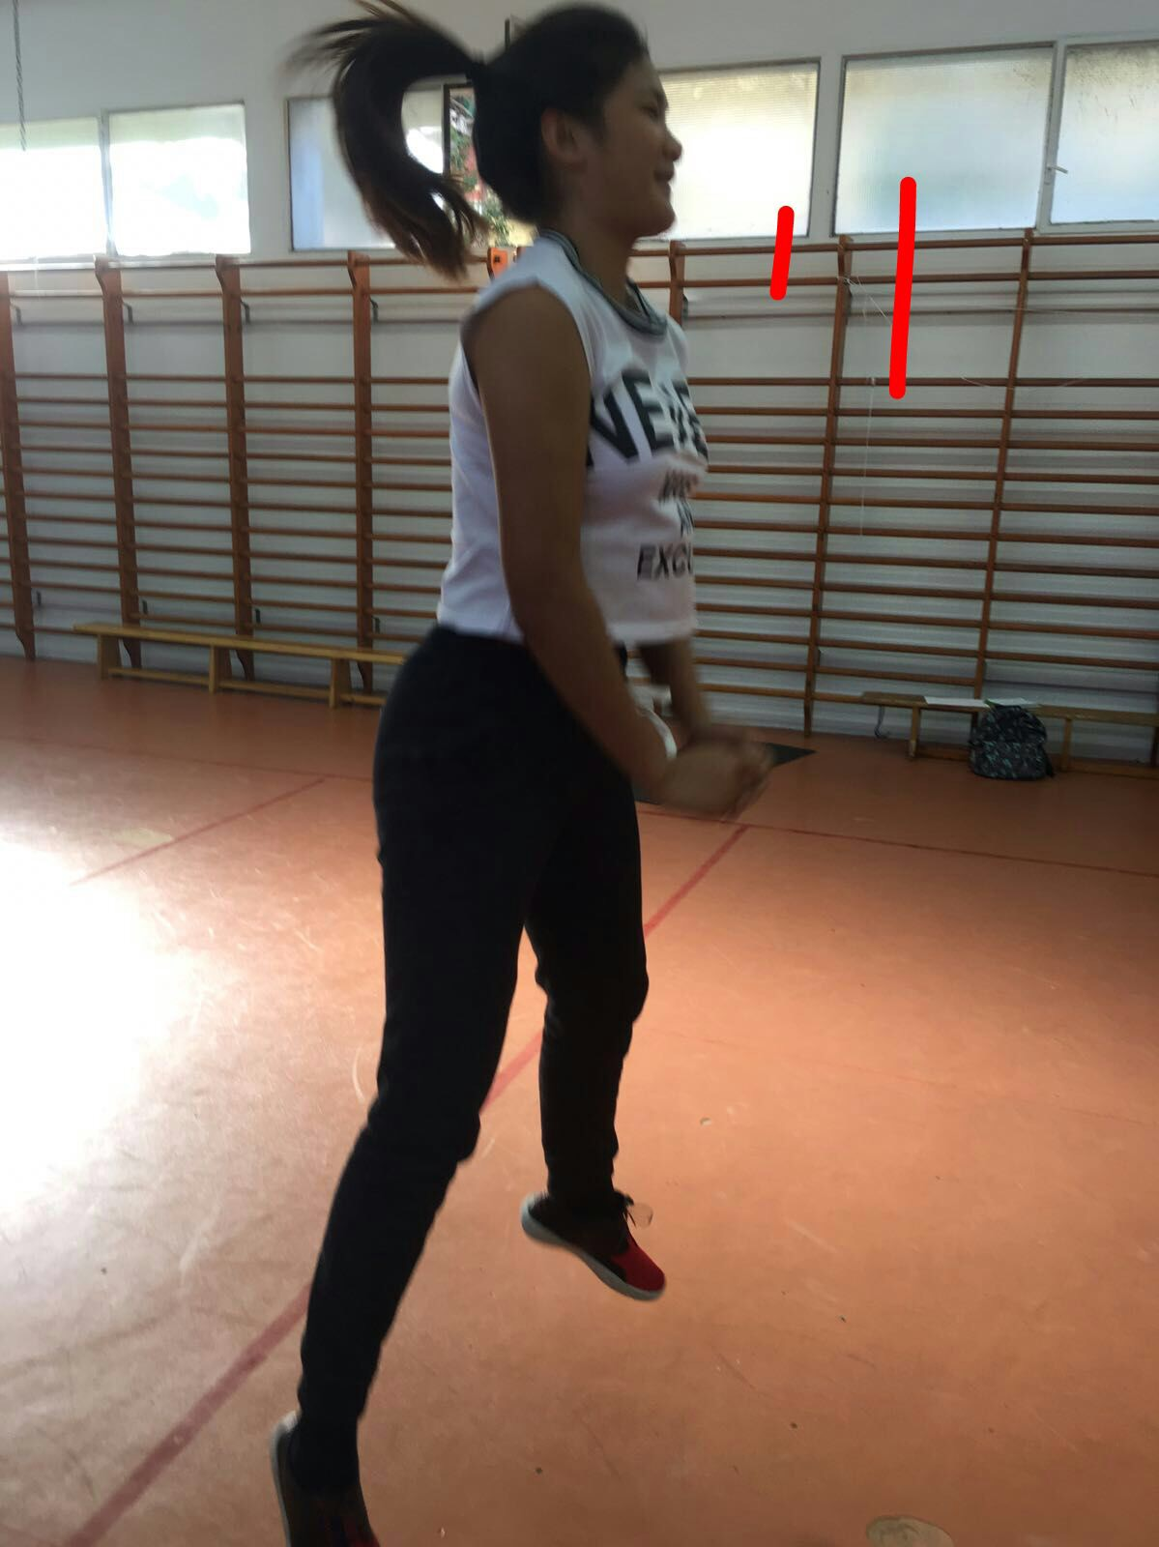

Activities in pair:

- Sumo squad 1’

2. Doble bycicle 1’

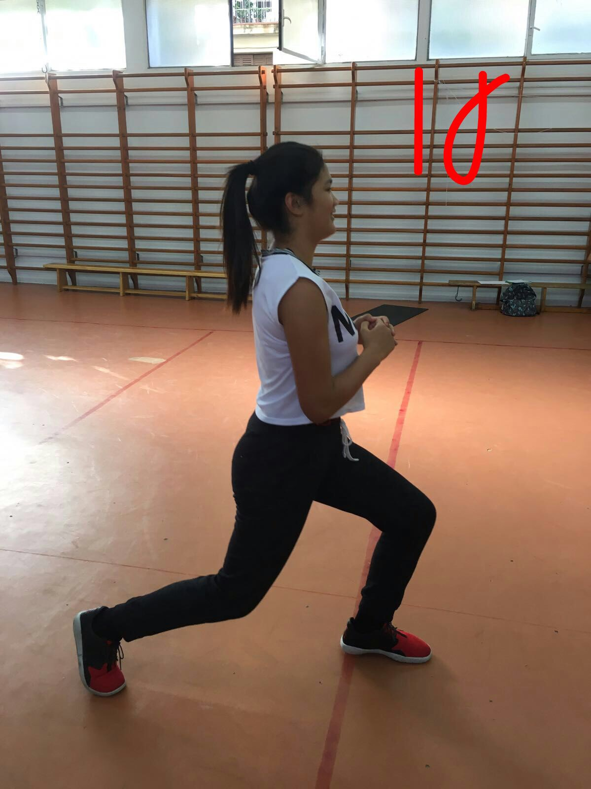
Activities in group:

- Zancada 5’

